Experiment 25: Sharpening of Image using Gradient Masking
Software / Tools: Python · OpenCV (cv2) · NumPy

AIM
To sharpen/enhance edges of an image using gradient-based masks (Sobel-type kernels) that highlight the rate of intensity change.
ALGORITHM
1. Import OpenCV and NumPy.
2. Read the input image.
3. Define gradient kernels for X and Y directions (Sobel-like 3x3 masks).
4. Convolve the image with both kernels using cv2.filter2D().
5. Compute the gradient magnitude by combining both directional responses.
6. Blend the gradient magnitude with the original image to enhance edges.
7. Display and save the result.
PROGRAM (SOURCE CODE)
import cv2
import numpy as np

img = cv2.imread("image.jpg")

kx = np.array([[-1, -2, -1], [0, 0, 0], [1, 2, 1]])
ky = np.array([[-1, 0, 1], [-2, 0, 2], [-1, 0, 1]])

gx = cv2.filter2D(img, cv2.CV_64F, kx)
gy = cv2.filter2D(img, cv2.CV_64F, ky)

gradient = cv2.magnitude(gx[:, :, 0], gy[:, :, 0])
gradient = cv2.convertScaleAbs(gradient)
gradient_color = cv2.cvtColor(gradient, cv2.COLOR_GRAY2BGR)

sharpened = cv2.addWeighted(img, 1.0, gradient_color, 0.5, 0)

cv2.imshow("Gradient Masked Sharpening", sharpened)
cv2.waitKey(0)
cv2.destroyAllWindows()

OUTPUT
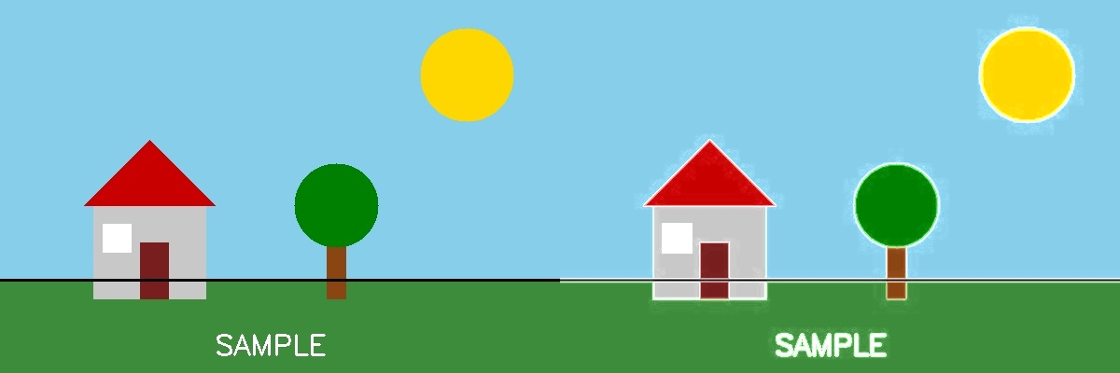
Fig. 25 — Output of Experiment 25: Sharpening of Image using Gradient Masking.
RESULT
Sharpen/enhance edges of an image using gradient-based masks (Sobel-type kernels) that highlight the rate of intensity change — completed successfully, as demonstrated in the output shown above.

